**VISVESVARAYA TECHNOLOGICAL UNIVERSITY**

**“Jnana Sangama”, Belgaum -590014, Karnataka.**



**LAB REPORT**

**on**

Artificial Intelligence (23CS5PCAIN)

***Submitted by***

**Chethan T M (1BM23CS076)**

***Submitted to***

***Prof.Swathi Sridharan***

Assistant Professor

Department of CSE, BMSCE

***in partial fulfilment for the award of the degree of***

**BACHELOR OF ENGINEERING**

***in***

**COMPUTER SCIENCE AND ENGINEERING**



**B.M.S. COLLEGE OF ENGINEERING**

**(Autonomous Institution under VTU)**

**BENGALURU-560019**

**Aug 2025 to Dec 2025**

**B.M.S. College of Engineering,**

**Bull Temple Road, Bangalore 560019**

(Affiliated To Visvesvaraya Technological University, Belgaum)

**Department of Computer Science and Engineering**



# CERTIFICATE

This is to certify that the Lab work entitled “Artificial Intelligence (23CS5PCAIN)” carried out by **Chethan T M (1BM23CS076),** who is a Bonafide student of **B.M.S. College of Engineering.** It is in partial fulfilment for the award of **Bachelor of Engineering in Computer Science and Engineering** of the Visvesvaraya Technological University, Belgaum. The Lab report has been approved as it satisfies the academic requirements in respect of an Artificial Intelligence (23CS5PCAIN) work prescribed for the said degree.

|  |  |
| --- | --- |
| **Swathi Sridharan**  Assistant Professor Department of CSE, BMSCE | **Dr. Kavitha Sooda** Professor & HOD  Department of CSE, BMSCE |

**Index**

|  |  |  |
| --- | --- | --- |
| **Sl.**  **No.** | **Experiment Title** | **Page No.** |
| 1 | Implement Tic –Tac –Toe Game Implement vacuum cleaner agent | 2-11 |
| 2 | Implement 8 puzzle problems using Iterative deepening search algorithm | 12-15 |
| 3 | Implement A* search algorithm | 16-20 |
| 4 | Implement Hill Climbing search algorithm to solve N-Queens problem | 21-24 |
| 5 | Simulated Annealing to Solve 8- Queens problem | 24-25 |
| 6 | Create a knowledge base using propositional logic and show that the given query entails the knowledge base or not. | 26-29 |
| 7 | Implement unification in first order logic | 30-33 |
| 8 | Create a knowledge base consisting of first order logic statements and prove the given query using Resolution | 34-35 |
| 9 | Create a knowledge base consisting of first order logic statements and prove the given query using forward reasoning. | 36-41 |
| 10 | Implement Alpha-Beta Pruning. | 42-44 |

GitHub Link: https://github.com/Chethushub/AI- Lab

**Certification Of The Assignment given:**



# Program 1

Implement Tic –Tac –Toe Game

# Algorithm:

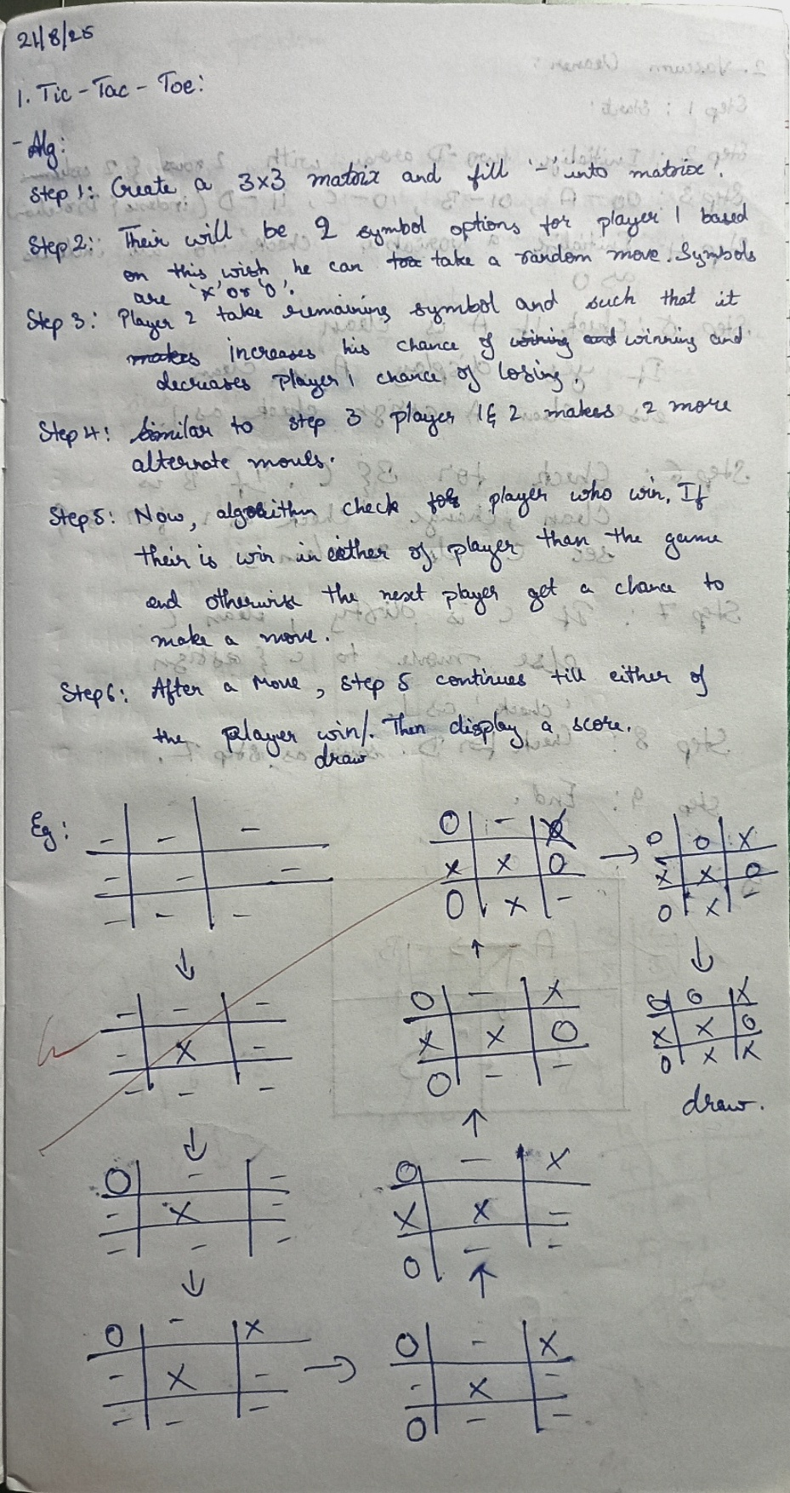

**Code:**

def print_board(board): print("\nCurrent Board:") for row in board:

print(row) print()

def check_winner(board, player): for i in range(3):

if all(cell == player for cell in board[i]): return True

if all(board[j][i] == player for j in range(3)): return True

if all(board[i][i] == player for i in range(3)): return True

if all(board[i][2 - i] == player for i in range(3)): return True

return False

def is_full(board):

return all(cell != " " for row in board for cell in row)

def tic_tac_toe():

board = [[" " for _ in range(3)] for _ in range(3)] current_player = "X"

move_count = 0

print("Tic-Tac-Toe Game (3x3 Matrix Format)\n") print_board(board)

while True: try:

row = int(input(f"Player {current_player}, enter row (0-2): ")) col = int(input(f"Player {current_player}, enter col (0-2): "))

except ValueError:

print("Please enter integers between 0 and 2.") continue

if not (0 <= row <= 2 and 0 <= col <= 2):

print("Invalid position. Try again.") continue

if board[row][col] != " ":

print("Cell already filled. Choose another.") continue

board[row][col] = current_player move_count += 1 print_board(board)

if check_winner(board, current_player): print(f"Player {current_player} wins!") break

if is_full(board): print("Game is a draw.") break

current_player = "O" if current_player == "X" else "X" print(f"Total moves (cost): {move_count}")

tic_tac_toe()

**Output case1:**

Tic-Tac-Toe Game (3x3 Matrix Format)

Current Board:

[' ', ' ', ' ']

[' ', ' ', ' ']

[' ', ' ', ' ']

Player X, enter row (0-2): 1

Player X, enter col (0-2): 1

Current Board:

[' ', ' ', ' ']

[' ', 'X', ' ']

[' ', ' ', ' ']

Player O, enter row (0-2): 0

Player O, enter col (0-2): 2

Current Board:

[' ', ' ', 'O']

[' ', 'X', ' ']

[' ', ' ', ' ']

Player X, enter row (0-2): 1

Player X, enter col (0-2): 0

Current Board:

[' ', ' ', 'O']

['X', 'X', ' ']

[' ', ' ', ' ']

Player O, enter row (0-2): 2

Player O, enter col (0-2): 1

Current Board:

[' ', ' ', 'O']

['X', 'X', ' ']

[' ', 'O', ' ']

Player X, enter row (0-2): 2

Player X, enter col (0-2): 2

Current Board:

[' ', ' ', 'O']

['X', 'X', ' ']

[' ', 'O', 'X']

Player O, enter row (0-2): 2

Player O, enter col (0-2): 0

Current Board:

[' ', ' ', 'O']

['X', 'X', ' ']

['O', 'O', 'X']

Player X, enter row (0-2): 0

Player X, enter col (0-2): 1

Current Board:

[' ', 'X', 'O']

['X', 'X', ' ']

['O', 'O', 'X']

Player O, enter row (0-2): 1

Player O, enter col (0-2): 2

Current Board:

[' ', 'X', 'O']

['X', 'X', 'O']

['O', 'O', 'X']

Player X, enter row (0-2): 0

Player X, enter col (0-2): 0

Current Board: ['X', 'X', 'O']

['X', 'X', 'O']

['O', 'O', 'X']

Player X wins!

Total moves (cost): 9

# Output case2:

Tic-Tac-Toe Game (3x3 Matrix Format)

Current Board:

[' ', ' ', ' ']

[' ', ' ', ' ']

[' ', ' ', ' ']

Player X, enter row (0-2): 0

Player X, enter col (0-2): 2

Current Board:

[' ', ' ', 'X']

[' ', ' ', ' ']

[' ', ' ', ' ']

Player O, enter row (0-2): 2

Player O, enter col (0-2): 1

Current Board:

[' ', ' ', 'X']

[' ', ' ', ' ']

[' ', 'O', ' ']

Player X, enter row (0-2): 0

Player X, enter col (0-2): 0

Current Board:

['X', ' ', 'X']

[' ', ' ', ' ']

[' ', 'O', ' ']

Player O, enter row (0-2): 0

Player O, enter col (0-2): 1

Current Board:

['X', 'O', 'X']

[' ', ' ', ' ']

[' ', 'O', ' ']

Player X, enter row (0-2): 2

Player X, enter col (0-2): 0

Current Board:

['X', 'O', 'X']

[' ', ' ', ' ']

['X', 'O', ' ']

Player O, enter row (0-2): 1

Player O, enter col (0-2): 1

Current Board: ['X', 'O', 'X']

[' ', 'O', ' ']

['X', 'O', ' ']

Player O wins!

Total moves (cost): 6

# Output case3:

Tic-Tac-Toe Game (3x3 Matrix Format):

Current Board:

[' ', ' ', ' ']

[' ', ' ', ' ']

[' ', ' ', ' ']

Player X, enter row (0-2): 1

Player X, enter col (0-2): 0 Current Board:

[' ', ' ', ' ']

['X', ' ', ' ']

[' ', ' ', ' ']

Player O, enter row (0-2): 0

Player O, enter col (0-2): 2

Current Board:

[' ', ' ', 'O']

['X', ' ', ' ']

[' ', ' ', ' ']

Player X, enter row (0-2): 2

Player X, enter col (0-2): 0

Current Board:

[' ', ' ', 'O']

['X', ' ', ' ']

['X', ' ', ' ']

Player O, enter row (0-2): 0

Player O, enter col (0-2): 0

Current Board:

['O', ' ', 'O']

['X', ' ', ' ']

['X', ' ', ' ']

Player X, enter row (0-2): 0

Player X, enter col (0-2): 1

Current Board:

['O', 'X', 'O']

['X', ' ', ' ']

['X', ' ', ' ']

Player O, enter row (0-2): 2

Player O, enter col (0-2): 1

Current Board:

['O', 'X', 'O']

['X', ' ', ' ']

['X', 'O', ' ']

Player X, enter row (0-2): 2

Player X, enter col (0-2): 2

Current Board:

['O', 'X', 'O']

['X', ' ', ' ']

['X', 'O', 'X']

Player O, enter row (0-2): 1

Player O, enter col (0-2): 1

Current Board:

['O', 'X', 'O']

['X', 'O', ' ']

['X', 'O', 'X']

Player X, enter row (0-2): 1

Player X, enter col (0-2): 2

Current Board: ['O', 'X', 'O']

['X', 'O', 'X']

['X', 'O', 'X']

Game is a draw.

Total moves (cost): 9

Implement vacuum cleaner agent

# Algorithm:

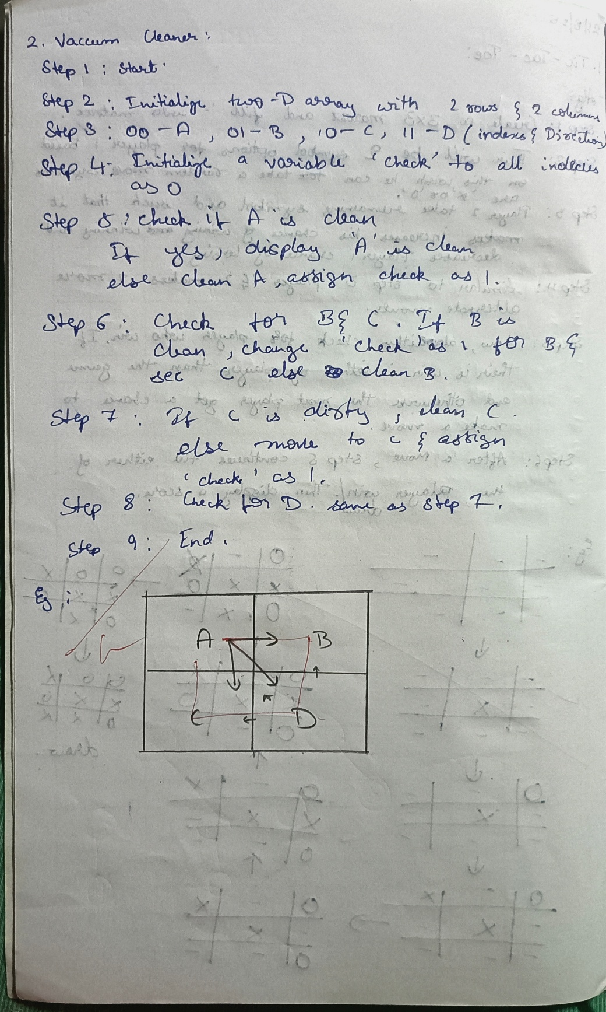

**Code:**

def vacuum_cleaner()

A = int(input("Enter state of A (0 for clean, 1 for dirty): "))

B = int(input("Enter state of B (0 for clean, 1 for dirty): ")) location = input("Enter location (A or B): ").upper()

cost = 0

state = {'A': A, 'B': B}

if location == 'A':

if state['A'] == 1: # If A is dirty

print("Cleaned A.") state['A'] = 0

cost += 1 else:

print("A is clean")

if state['B'] == 1: # If B is dirty print("Moving vacuum right") print("Cleaned B.")

state['B'] = 0

cost += 1

print("Is B clean now? (0 if clean, 1 if dirty):", state['B']) print("Is A dirty? (0 if clean, 1 if dirty):", state['A']) print("B is clean")

print("Moving vacuum left") else:

print("Turning vacuum off")

elif location == 'B':

if state['B'] == 1: # If B is dirty print("Cleaned B.")

state['B'] = 0

cost += 1 else:

print("B is clean")

if state['A'] == 1: # If A is dirty print("Moving vacuum left") print("Cleaned A.")

state['A'] = 0

cost += 1

print("Is A clean now? (0 if clean, 1 if dirty):", state['A']) print("Is B dirty? (0 if clean, 1 if dirty):", state['B']) print("A is clean")

print("Moving vacuum right") else:

print("Turning vacuum off")

print("Cost:", cost) print(state)

vacuum_cleaner()

**OUTPUT Case1:**

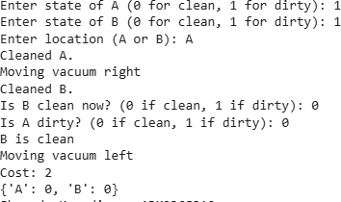

**OUTPUT Case2:**

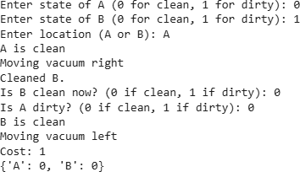

**OUTPUT Case3:**

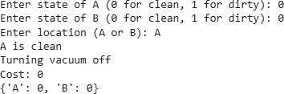

**Program2**

Implement 8 puzzle problem using Iterative deepening search algorithm

**Algorithm:**

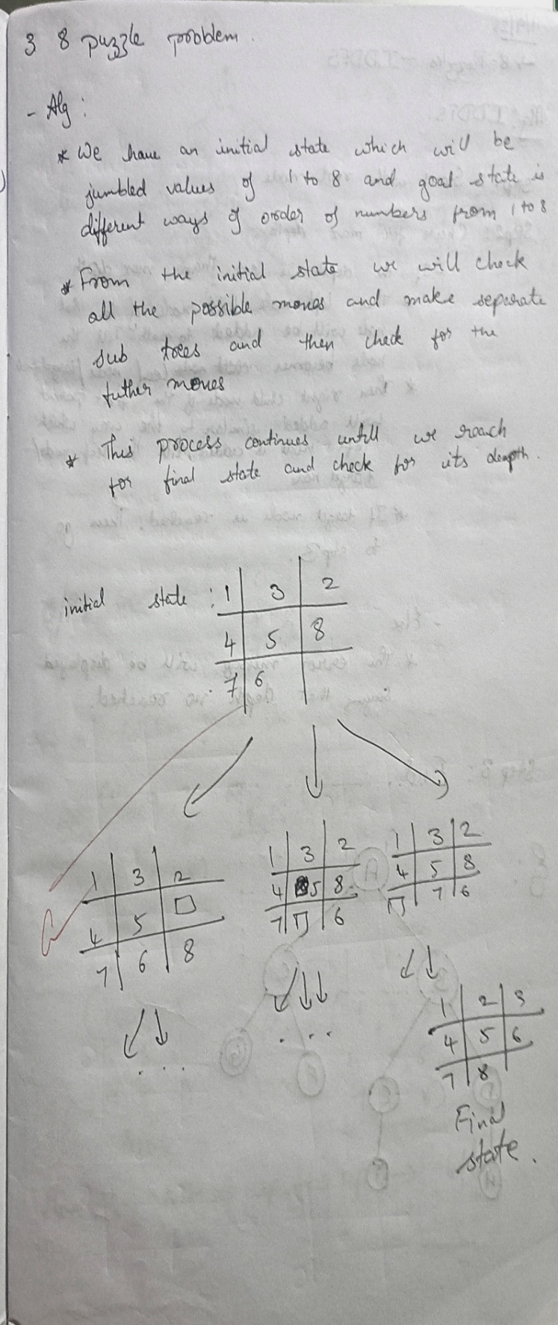 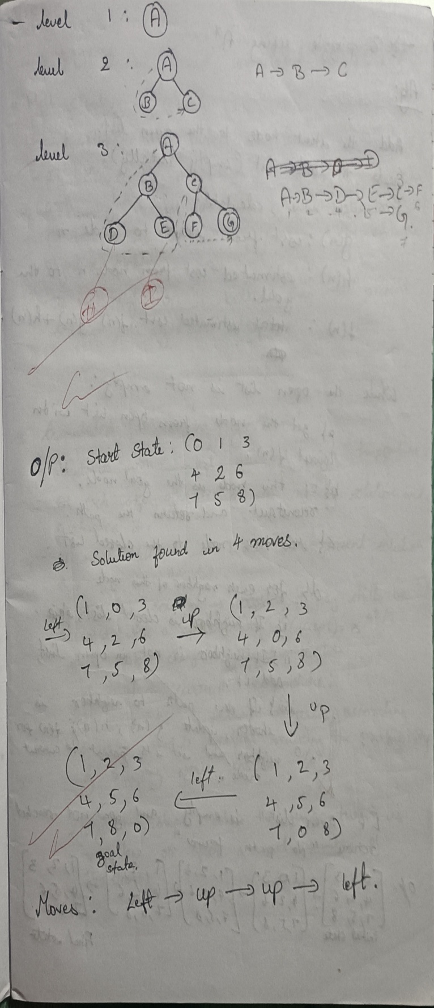

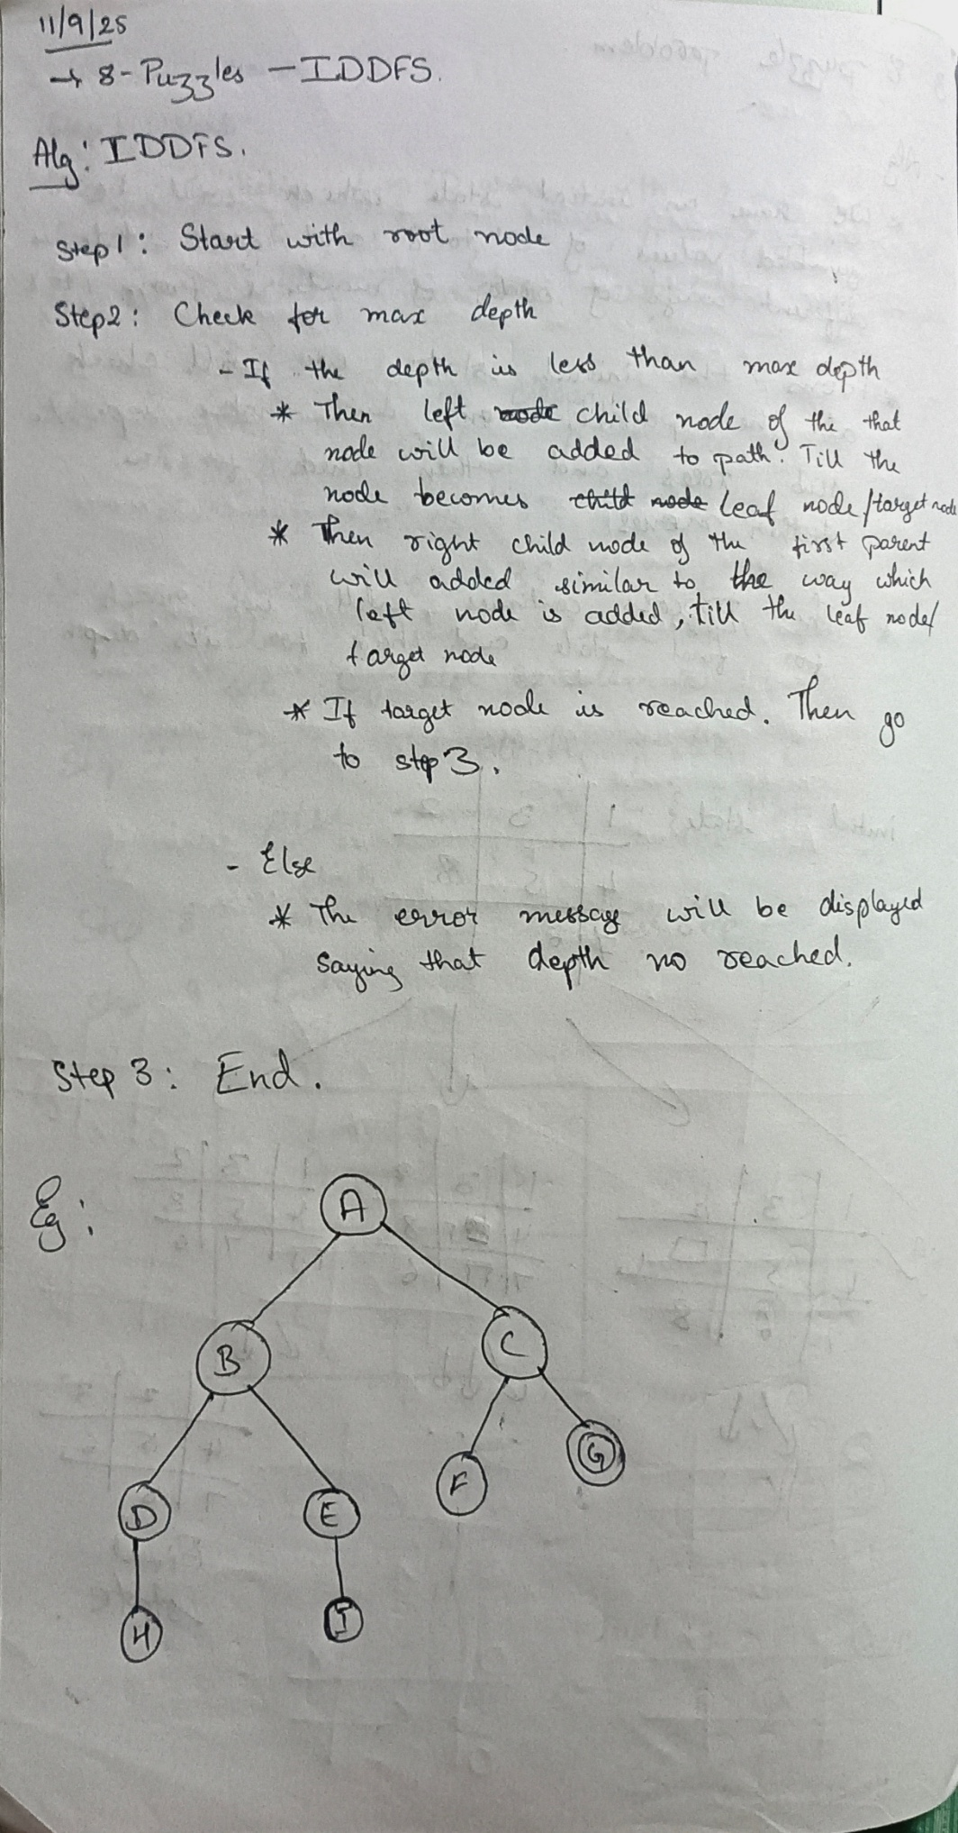

**Code:**

def get_neighbors(state): neighbors = []

idx = state.index("0")

moves = [(-1, 0), (1, 0), (0, -1), (0, 1)]

x, y = divmod(idx, 3)

for dx, dy in moves:

nx, ny = x + dx, y + dy

if 0 <= nx < 3 and 0 <= ny < 3: new_idx = nx * 3 + ny state_list = list(state)

state_list[idx], state_list[new_idx] = state_list[new_idx], state_list[idx] neighbors.append("".join(state_list))

return neighbors

def dfs_limit(start_state, goal_state, limit): stack = [(start_state, 0)]

visited = set()

parent = {start_state: None} path = []

while stack:

current_state, depth = stack.pop()

if current_state == goal_state: while current_state:

path.append(current_state) current_state = parent[current_state]

return path[::-1]

if depth < limit and current_state not in visited: visited.add(current_state)

neighbors = get_neighbors(current_state) neighbors.reverse() # Maintain consistent exploration order for neighbor in neighbors:

if neighbor not in visited: parent[neighbor] = current_state stack.append((neighbor, depth + 1))

return None

def iddfs(start_state, goal_state, max_depth): for limit in range(max_depth + 1):

print(f"Searching with depth limit: {limit}") solution = dfs_limit(start_state, goal_state, limit) if solution:

return solution return None

print("Enter the initial state (enter 3 digits per row, separated by spaces, 0 for empty):") initial_state_rows = []

for i in range(3):

row = input(f"Row {i+1}: ").split() initial_state_rows.extend(row)

initial_state = "".join(initial_state_rows)

print("\nEnter the goal state (enter 3 digits per row, separated by spaces, 0 for empty):") goal_state_rows = []

for i in range(3):

row = input(f"Row {i+1}: ").split() goal_state_rows.extend(row)

goal_state = "".join(goal_state_rows) max_depth = 50

solution = iddfs(initial_state, goal_state, max_depth)

if solution:

print("\nIDDFS solution path:") for s in solution:

print(s[:3])

print(s[3:6])

print(s[6:]) print()

else:

print(f"\nNo solution found within the maximum depth of {max_depth}.")

**Output:**

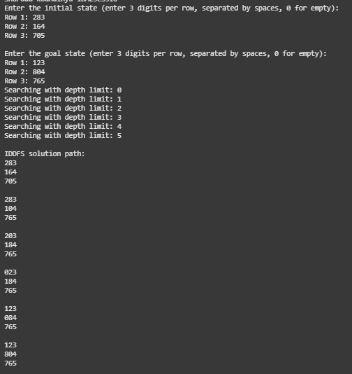

# Program3

Implement A* search algorithm

**Algorithm:**

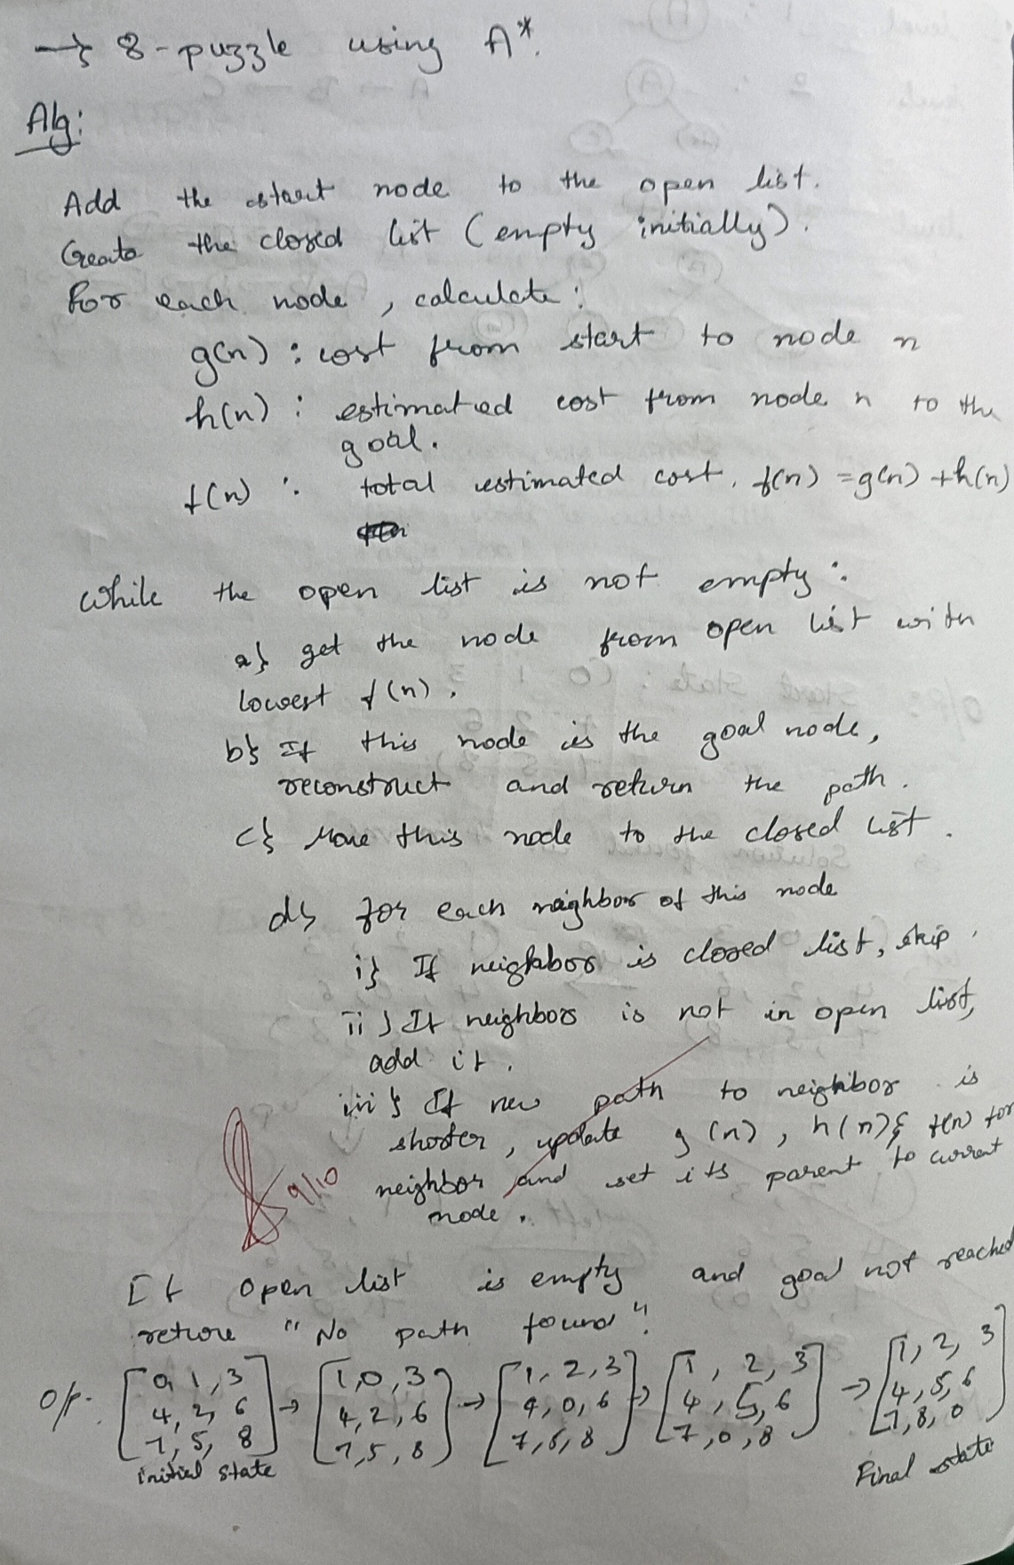

**Code:**

#MISPLACED TILE

import heapq

from itertools import count

def misplaced_heuristic(board, goal):

"""h(n): number of tiles not in their goal position (excluding blank 0).""" n = len(board)

misplaced = 0 for i in range(n):

for j in range(n):

if board[i][j] != 0 and board[i][j] != goal[i][j]: misplaced += 1

return misplaced

def find_blank(board): n = len(board)

for i in range(n): for j in range(n):

if board[i][j] == 0: return i, j

raise ValueError("Board does not contain a blank tile (0)")

def neighbors(board):

"""Generate neighboring boards by sliding one tile into the blank.""" n = len(board)

x, y = find_blank(board)

dirs = [(0,1),(0,-1),(1,0),(-1,0)]

res = []

for dx, dy in dirs:

nx, ny = x + dx, y + dy

if 0 <= nx < n and 0 <= ny < n:

b = [list(row) for row in board] b[x][y], b[nx][ny] = b[nx][ny], b[x][y]

res.append(tuple(tuple(row) for row in b)) return res

def flatten(board):

return [x for row in board for x in row]

def inversion_count(seq):

arr = [x for x in seq if x != 0] inv = 0

for i in range(len(arr)):

for j in range(i+1, len(arr)): if arr[i] > arr[j]:

inv += 1 return inv

def blank_row_from_bottom(board): n = len(board)

for i in range(n):

for j in range(n):

if board[i][j] == 0: return n - i

raise ValueError("Board does not contain a blank tile (0)")

def is_solvable(start, goal):

"""General n-puzzle solvability test (odd/even width).""" n = len(start)

start_flat = flatten(start) goal_flat = flatten(goal)

pos = {val: idx for idx, val in enumerate(goal_flat)} start_perm = [pos[val] for val in start_flat]

inv = inversion_count(start_perm) if n % 2 == 1:

# odd grid: inversions parity must be even

return inv % 2 == 0 else:

# even grid: blank row from bottom parity matters blank_row = blank_row_from_bottom(start) goal_blank_row = blank_row_from_bottom(goal)

# When using relative permutation to goal, parity of blank rows must match return (inv + blank_row) % 2 == (0 + goal_blank_row) % 2

def reconstruct_path(came_from, current): path = [current]

while current in came_from: current = came_from[current] path.append(current)

path.reverse() return path

def a_star_misplaced(start, goal):

start = tuple(tuple(row) for row in start) goal = tuple(tuple(row) for row in goal)

if len(start) != len(start[0]) or len(goal) != len(goal[0]) or len(start) != len(goal): raise ValueError("Initial and goal must be square boards of the same size.")

start_vals = sorted(flatten(start)) goal_vals = sorted(flatten(goal)) if start_vals != goal_vals:

raise ValueError("Initial and goal must contain the same set of tiles.")

if not is_solvable(start, goal):

return None, None, 0, 0 # unsolvable counter = count() # tie-breaker

h0 = misplaced_heuristic(start, goal)

g_score = {start: 0} f0 = h0

open_heap = [(f0, next(counter), start)] open_set = {start: f0}

closed = set() came_from = {}

expansions = 0 while open_heap:

_, _, current = heapq.heappop(open_heap) if current in closed:

continue closed.add(current)

if current == goal:

path = reconstruct_path(came_from, current)

return path, g_score[current], expansions, len(closed) expansions += 1

for nb in neighbors(current): tentative_g = g_score[current] + 1 if nb in closed:

continue

if nb not in g_score or tentative_g < g_score[nb]: came_from[nb] = current

g_score[nb] = tentative_g

h = misplaced_heuristic(nb, goal) f = tentative_g + h

if nb not in open_set or f < open_set[nb]: heapq.heappush(open_heap, (f, next(counter), nb)) open_set[nb] = f

return None, None, expansions, len(closed) def read_board(n, prompt):

print(prompt) board = []

for i in range(n):

row = list(map(int, input().split())) if len(row) != n:

raise ValueError(f"Row {i+1} must contain exactly {n} integers.") board.append(row)

return board

def print_board(board): for row in board:

print(" ".join(f"{x}" for x in row))

def main():

try:

n = int(input("Enter puzzle size n (e.g., 3 for 3x3): ").strip())

initial = read_board(n, "Enter initial state row by row (use 0 for blank):") goal = read_board(n, "Enter goal state row by row (use 0 for blank):")

result = a_star_misplaced(initial, goal) path, cost, expansions, explored = result

if path is None:

print("No solution (unsolvable with given start/goal).") return

print("\nSolution path (each state shows g, h, f):\n") for idx, state in enumerate(path):

g = idx # each step costs 1

h = misplaced_heuristic(state, tuple(tuple(r) for r in goal)) f = g + h

print(f"Step {idx}: g={g}, h={h}, f={f}") print_board(state)

print()

print(f"Total cost (number of moves): {cost}") print(f"Nodes expanded: {expansions}") print(f"Nodes explored (unique): {explored}")

except Exception as e: print("Error:", e)

if name == " main ": main()

**Output:**

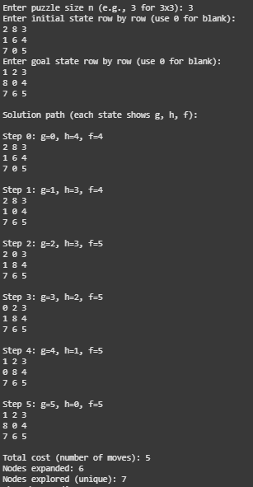

# Program4

Implement Hill Climbing search algorithm to solve N-Queens problem

# Algorithm:

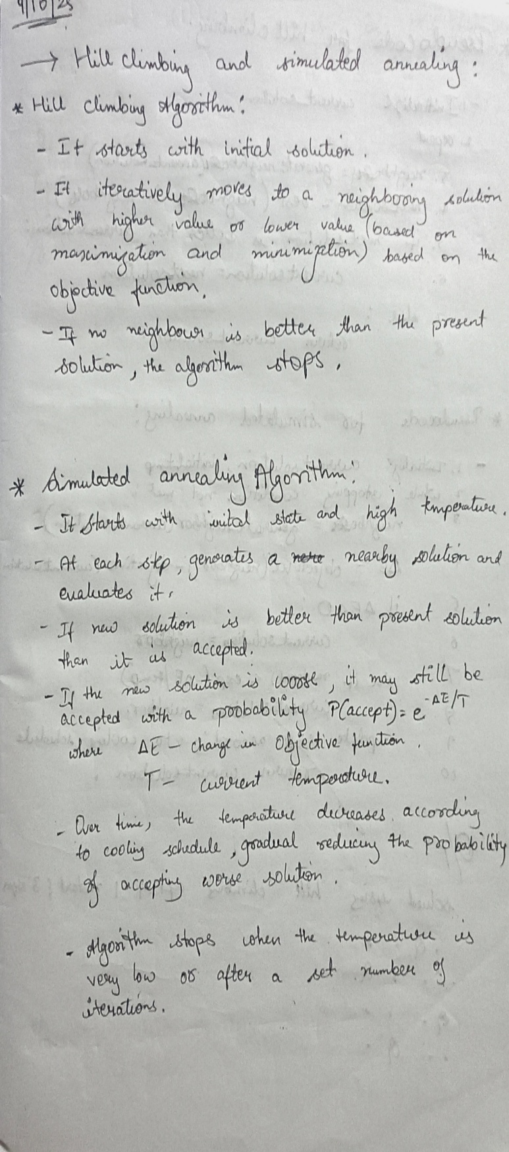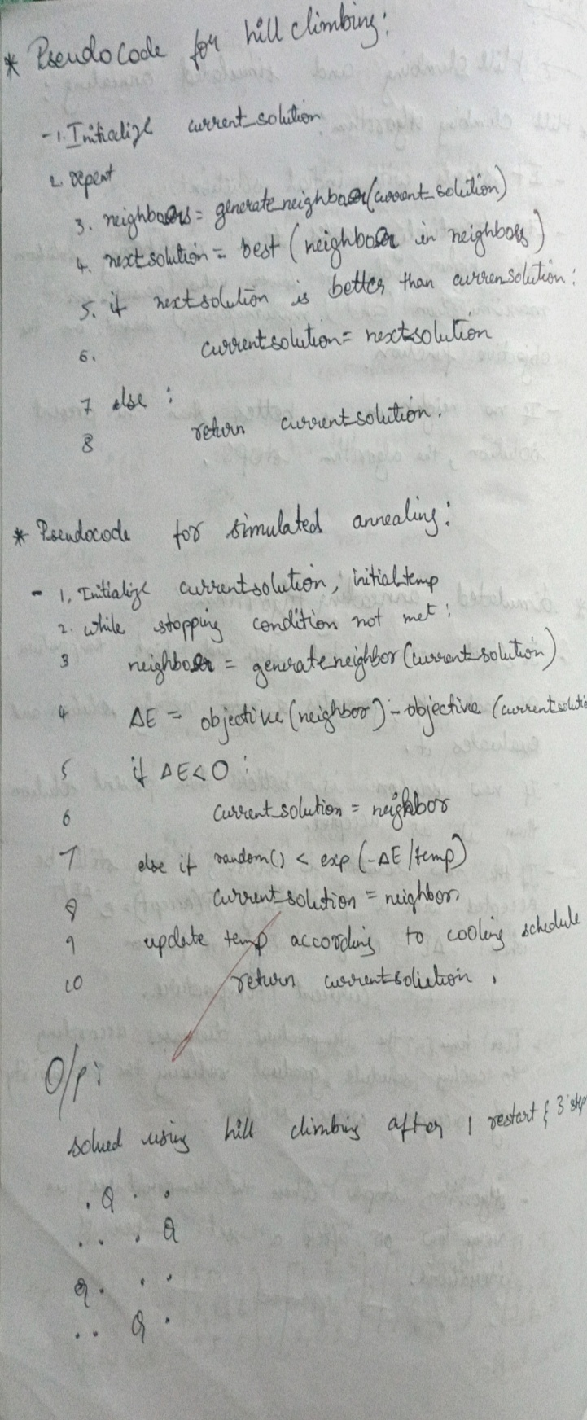

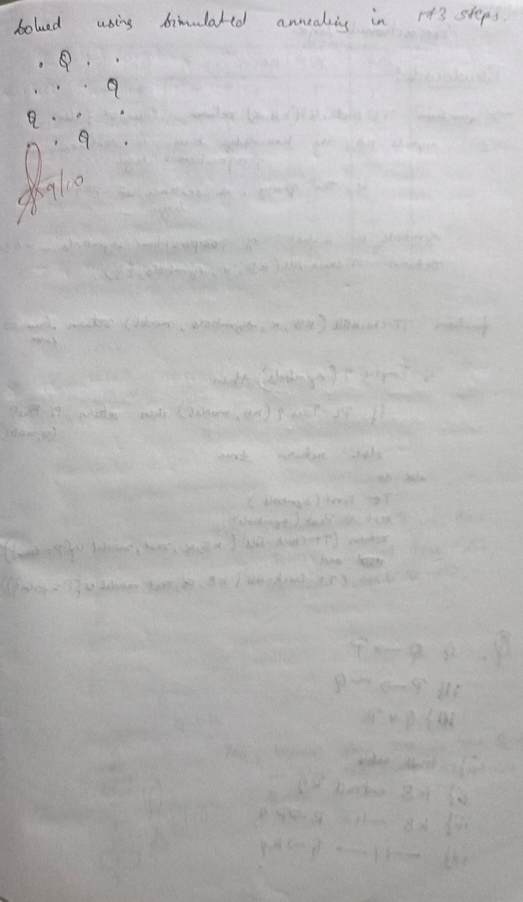

# Code:

def calculate_cost(state): cost = 0

n = len(state) for i in range(n):

for j in range(i + 1, n):

if state[i] == state[j] or abs(state[i] - state[j]) == abs(i - j): cost += 1

return cost

def generate_neighbors(state): neighbors = []

n = len(state)

for col in range(n): for row in range(n):

if state[col] != row: # move queen

new_state = list(state) new_state[col] = row neighbors.append(new_state)

return neighbors

def hill_climbing(initial_state): current = initial_state

current_cost = calculate_cost(current) step = 0

print(f"Step {step}: State = {current}, Cost = {current_cost}") while True:

neighbors = generate_neighbors(current)

neighbor_costs = [(n, calculate_cost(n)) for n in neighbors]

# Print state space for this step print("\nNeighbors and their costs:") for n, c in neighbor_costs:

print(f" {n} -> Cost = {c}")

# Pick the best neighbor (lowest cost)

best_neighbor, best_cost = min(neighbor_costs, key=lambda x: x[1])

if best_cost >= current_cost: break

step += 1

current, current_cost = best_neighbor, best_cost

print(f"\nStep {step}: Move to {current}, Cost = {current_cost}")

if current_cost == 0:

print("\nGoal reached! Solution found.") break

initial_state = [3, 1, 2, 0] hill_climbing(initial_state) **Output:**

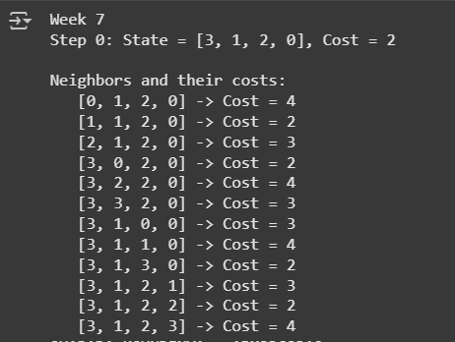

Simulated Annealing to Solve 8-Queens problem

**Code:**

import random import math

def calculate_cost(state): cost = 0

n = len(state) for i in range(n):

for j in range(i + 1, n):

if state[i] == state[j] or abs(state[i] - state[j]) == abs(i - j): cost += 1

return cost

def get_random_neighbor(state): n = len(state)

new_state = list(state)

col = random.randint(0, n - 1) row = random.randint(0, n - 1) new_state[col] = row

return new_state

def simulated_annealing(n=8, max_iterations=10000, initial_temp=100.0, cooling_rate=0.99): current = [random.randint(0, n - 1) for _ in range(n)]

current_cost = calculate_cost(current) best = current

best_cost = current_cost temperature = initial_temp

for _ in range(max_iterations): if current_cost == 0:

break

neighbor = get_random_neighbor(current) neighbor_cost = calculate_cost(neighbor) delta = neighbor_cost - current_cost

if delta < 0 or random.random() < math.exp(-delta / temperature): current, current_cost = neighbor, neighbor_cost

if current_cost < best_cost:

best, best_cost = current, current_cost

temperature *= cooling_rate if temperature < 1e-6:

break

return best, best_cost

best_state, best_cost = simulated_annealing()

print("The best position found:", best_state) print("cost =", best_cost)

# Output:



**Program 6**

Create a knowledge base using propositional logic and show that the given query entails the knowledge base or not.

# Algorithm:

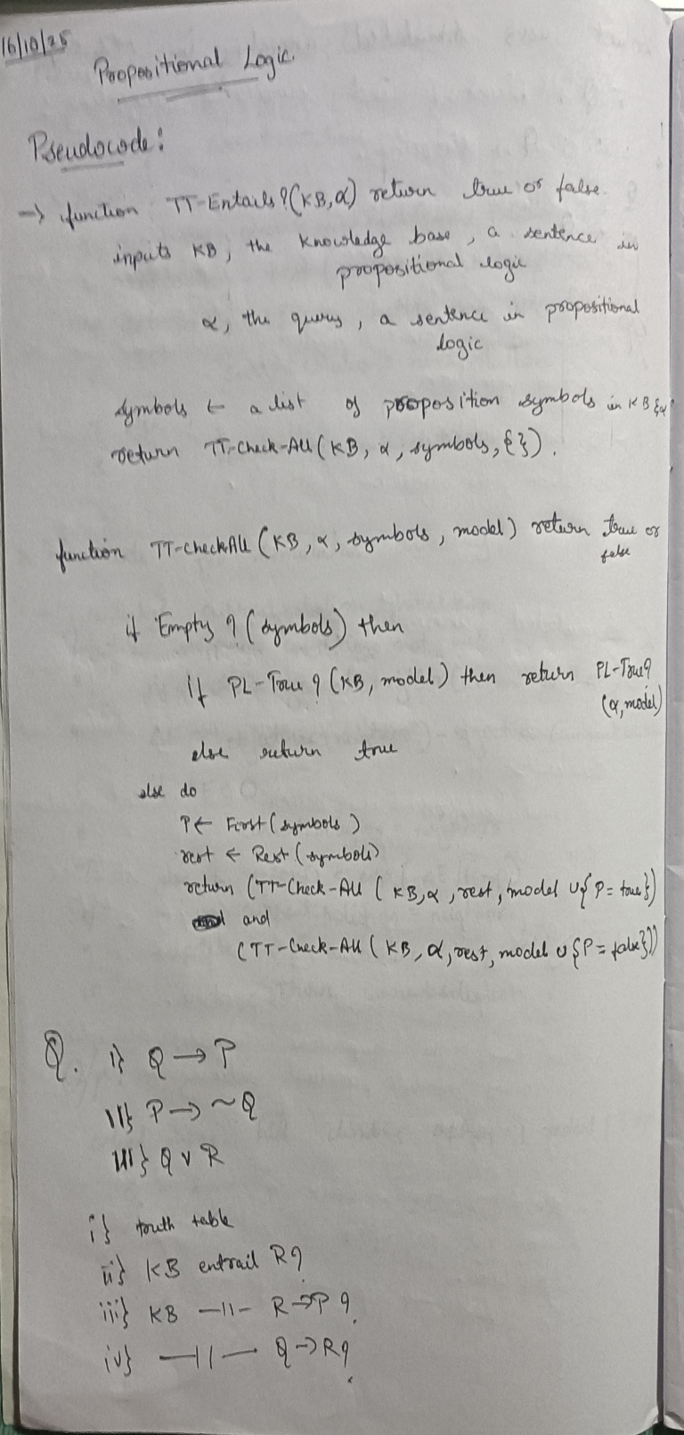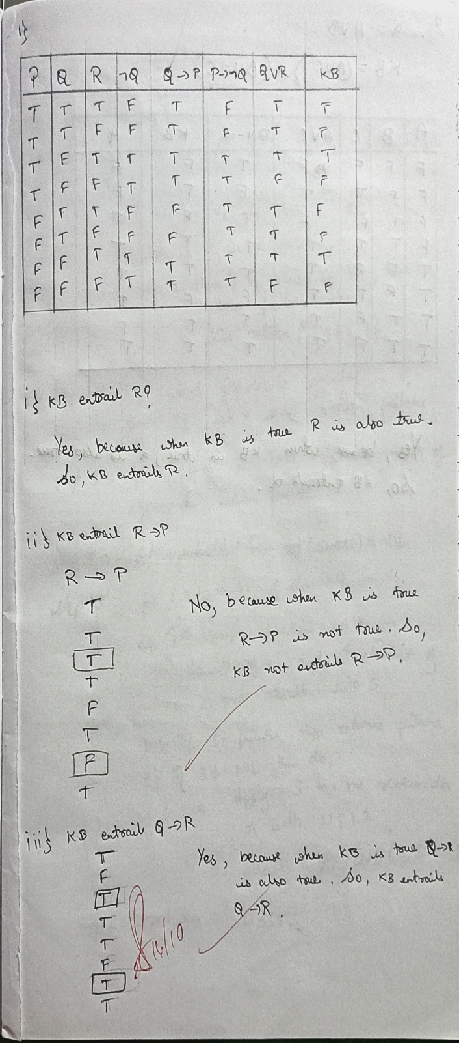

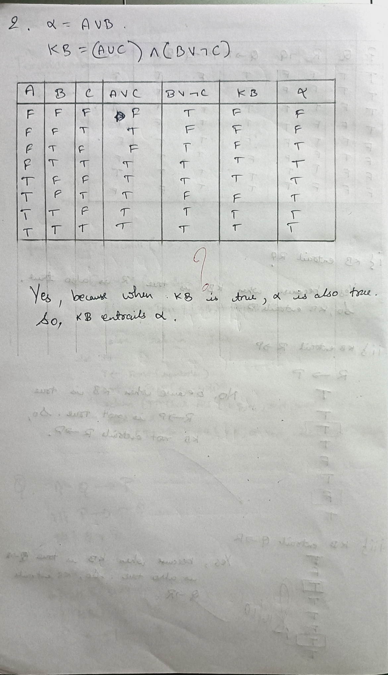

**Code:**

import itertools

def eval_expr(expr, model): try:

return eval(expr, {}, model) except:

return False

def tt_entails(KB, query):

symbols = sorted(set([ch for ch in KB + query if ch.isalpha()]))

print("\nTruth Table:")

print(" | ".join(symbols) + " | KB | Query") print("-" * (6 * len(symbols) + 20))

entails = True

for values in itertools.product([False, True], repeat=len(symbols)): model = dict(zip(symbols, values))

kb_val = eval_expr(KB, model)

query_val = eval_expr(query, model)

row = " | ".join(["T" if model[s] else "F" for s in symbols]) print(f"{row} | {kb_val} | {query_val}")

if kb_val and not query_val: entails = False

return entails

KB = input("Enter Knowledge Base (use &, |, ~ for AND, OR, NOT): ") query = input("Enter Query: ")

result = tt_entails(KB, query) print("\nResult:")

if result:

print("KB entails Query (True in all cases).") else:

print("KB does NOT entail Query.")

# Output:

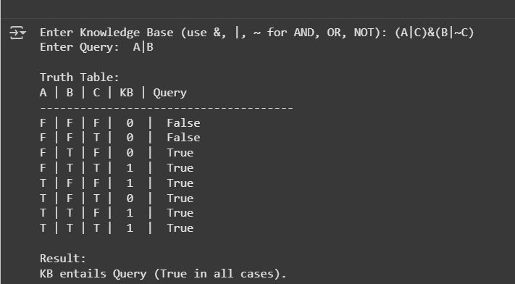

**Program 7**

Implement unification in first order logic

**Algorithm:**

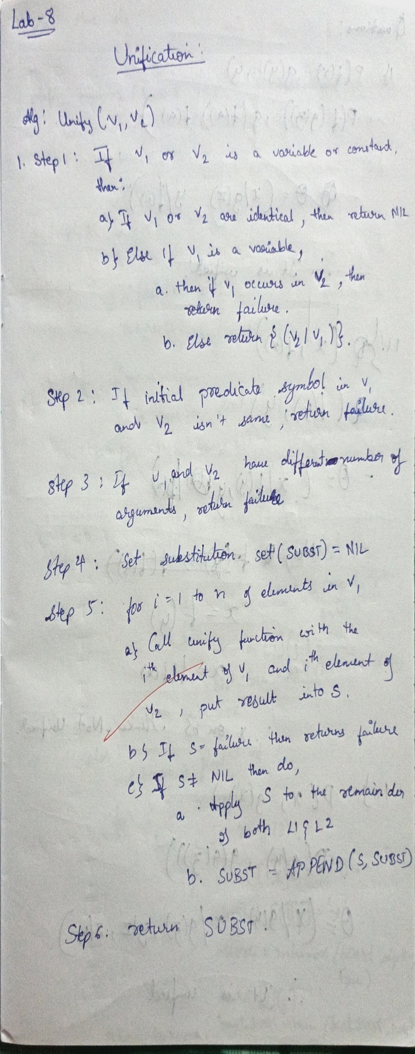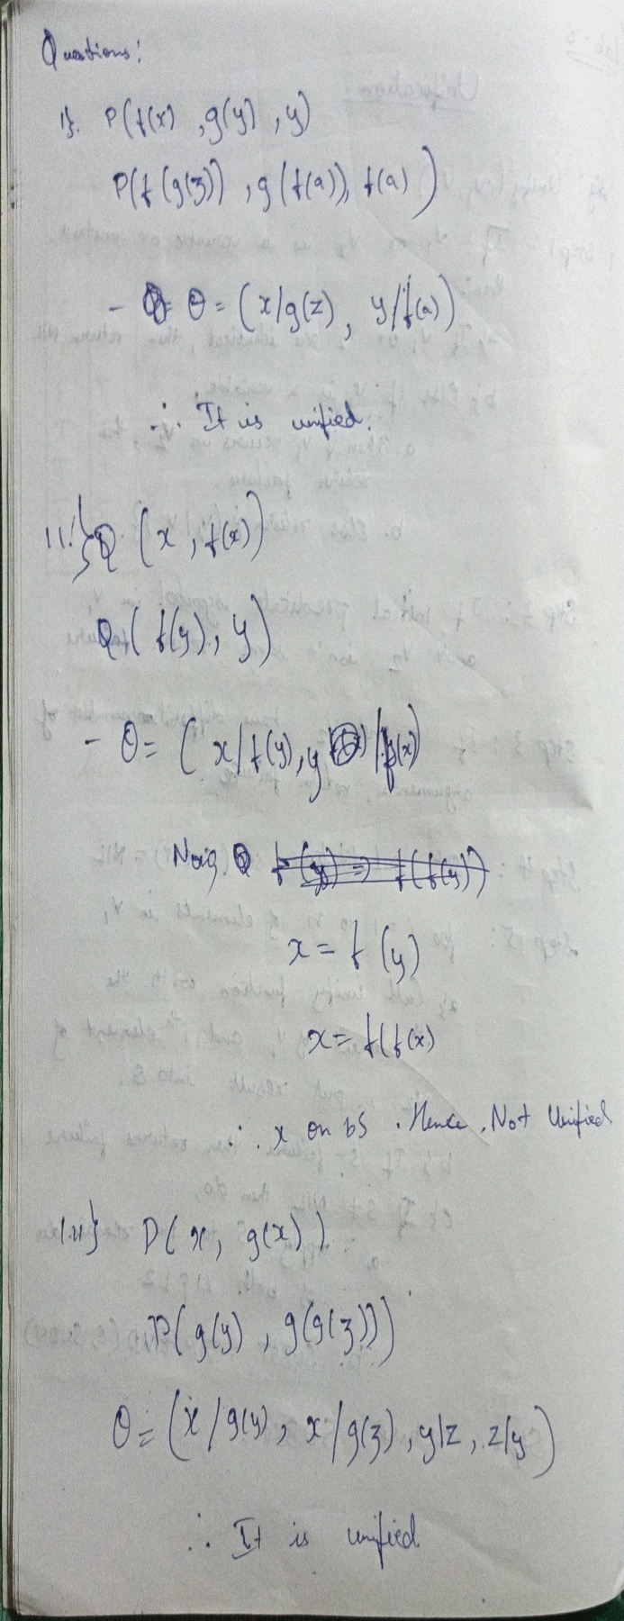

# 

**Code:**

def occurs_check(var, term, subst): if var == term:

return True

elif isinstance(term, tuple):

return any(occurs_check(var, t, subst) for t in term) elif term in subst:

return occurs_check(var, subst[term], subst) return False

def unify(x, y, subst): if subst is None: return None

elif x == y: return subst

elif isinstance(x, str) and x.isupper(): return unify_var(x, y, subst)

elif isinstance(y, str) and y.isupper(): return unify_var(y, x, subst)

elif isinstance(x, tuple) and isinstance(y, tuple): if x[0] != y[0] or len(x) != len(y):

return None

for a, b in zip(x[1:], y[1:]): subst = unify(a, b, subst) if subst is None:

return None return subst

else:

return None

def unify_var(var, x, subst): if var in subst:

return unify(subst[var], x, subst) elif x in subst:

return unify(var, subst[x], subst) elif occurs_check(var, x, subst):

return None else:

subst[var] = x return subst

def parse_expr(s):

s = s.replace(" ", "") if '(' not in s:

return s

name_end = s.index('(') name = s[:name_end] args = []

depth = 0 current = ""

for c in s[name_end+1:-1]: if c == ',' and depth == 0:

args.append(parse_expr(current)) current = ""

else:

if c == '(': depth += 1

elif c == ')': depth -= 1

current += c if current:

args.append(parse_expr(current)) return tuple([name] + args)

def expr_to_str(expr):

if isinstance(expr, tuple):

return expr[0] + "(" + ",".join(expr_to_str(e) for e in expr[1:]) + ")" else:

return expr

expr1_input = input("Enter first expression: ") expr2_input = input("Enter second expression: ")

expr1 = parse_expr(expr1_input) expr2 = parse_expr(expr2_input)

subst = unify(expr1, expr2, {}) if subst:

formatted_subst = {var: expr_to_str(val) for var, val in subst.items()}

else:

formatted_subst = None

print("Most General Unifier (MGU):", formatted_subst)

# Output:

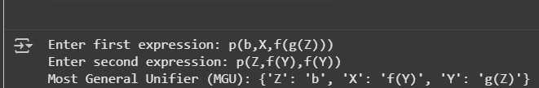

**Program 8**

Create a knowledge base consisting of first order logic statements and prove the given query by resolution.

# Algorithm:

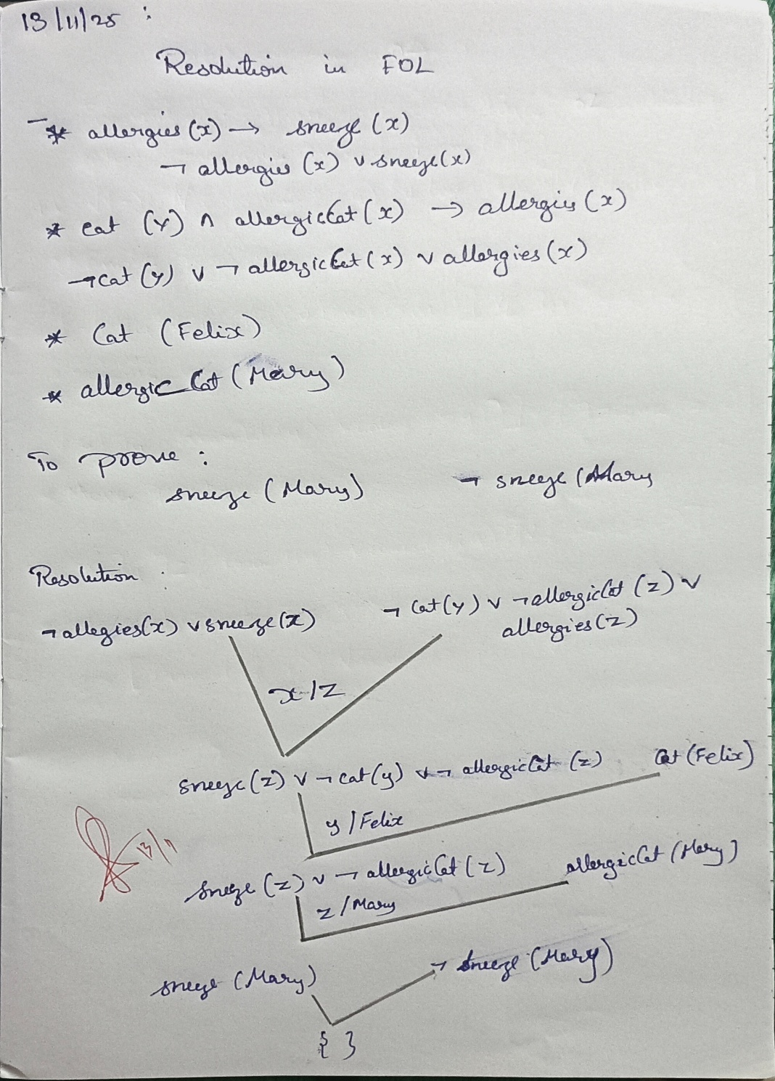

**Code:**

facts = { 'American(Robert)': True, 'Hostile(A)': True,

'Sells_Weapons(Robert, A)': True

}

If American(X) and Hostile(Y) and Sells_Weapons(X, Y), then Crime(X) def forward_reasoning(facts):

If American(X) and Hostile(Y) and Sells_Weapons(X, Y), then Crime(X)

if facts.get('American(Robert)', False) and facts.get('Hostile(A)', False) and facts.get('Sells_Weapons(Robert, A)', False):

facts['Crime(Robert)'] = True forward_reasoning(facts)

if facts.get('Crime(Robert)', False): print("Robert is a criminal.")

else:

print("Robert is not a criminal.")

# Output:

Robert is a criminal.

# Program 9

Create a knowledge base consisting of first order logic statements and prove the given query using forward reasoning.

# Algorithm:

# 

**Code:**

import copy

#

# Predicate Structure #

class Predicate:

def init (self, name, args, negated=False): [self.name](http://self.name/) = name

self.args = args if isinstance(args, tuple) else tuple(args) self.negated = negated

def eq (self, other):

return ([self.name](http://self.name/) == [other.name](http://other.name/) and self.args == other.args and self.negated == other.negated)

def hash (self):

return hash(([self.name](http://self.name/), self.args, self.negated))

def repr (self):

neg = "~" if self.negated else ""

args_str = ",".join(str(a) for a in self.args) return f"{neg}{[self.name](http://self.name/)}({args_str})"

def negate(self):

return Predicate([self.name](http://self.name/), self.args, not self.negated)

def substitute(self, theta):

"""Apply substitution theta to this predicate"""

new_args = tuple(substitute_term(arg, theta) for arg in self.args) return Predicate([self.name](http://self.name/), new_args, self.negated)

def substitute_term(term, theta): """Apply substitution to a term"""

if isinstance(term, str) and term.islower(): # variable if term in theta:

return substitute_term(theta[term], theta) return term

elif isinstance(term, tuple):

return tuple(substitute_term(t, theta) for t in term) return term

#

# Unification Algorithm #

def unify(x, y, theta=None): if theta is None:

theta = {}

if theta == "FAIL": return "FAIL"

elif x == y: return theta

elif isinstance(x, str) and x.islower(): # variable return unify_var(x, y, theta)

elif isinstance(y, str) and y.islower(): # variable return unify_var(y, x, theta)

elif isinstance(x, tuple) and isinstance(y, tuple): if len(x) != len(y):

return "FAIL"

theta = unify(x[0], y[0], theta) if theta == "FAIL":

return "FAIL"

return unify(x[1:], y[1:], theta) else:

return "FAIL"

def unify_var(var, x, theta): if var in theta:

return unify(theta[var], x, theta)

elif isinstance(x, str) and x.islower() and x in theta: return unify(var, theta[x], theta)

elif occurs_check(var, x, theta): return "FAIL"

else:

new_theta = copy.deepcopy(theta) new_theta[var] = x

return new_theta

def occurs_check(var, x, theta): if var == x:

return True

elif isinstance(x, str) and x.islower() and x in theta: return occurs_check(var, theta[x], theta)

elif isinstance(x, tuple):

return any(occurs_check(var, xi, theta) for xi in x) return False

#

# Variable Standardization #

var_counter = 0

def standardize_variables(clause):

"""Rename all variables in a clause to unique names""" global var_counter

mapping = {} new_clause = []

for pred in clause: new_args = []

for arg in pred.args:

if isinstance(arg, str) and arg.islower(): # variable if arg not in mapping:

mapping[arg] = f"{arg}{var_counter}" var_counter += 1

new_args.append(mapping[arg]) else:

new_args.append(arg) new_clause.append(Predicate([pred.name](http://pred.name/), new_args, pred.negated))

return new_clause

#

# Resolution Algorithm #

def resolve(ci, cj):

"""Resolve two clauses using FOL resolution""" ci = standardize_variables(ci)

cj = standardize_variables(cj) resolvents = []

for i, pi in enumerate(ci): for j, pj in enumerate(cj):

# Check if predicates can be resolved (opposite signs, same name) if pi.negated != pj.negated and [pi.name](http://pi.name/) == [pj.name](http://pj.name/):

# Try to unify the arguments theta = unify(pi.args, pj.args)

if theta != "FAIL":

# Create resolvent by removing resolved predicates and applying substitution new_clause = []

# Add literals from ci except pi for k, pred in enumerate(ci):

if k != i:

new_clause.append(pred.substitute(theta))

# Add literals from cj except pj for k, pred in enumerate(cj):

if k != j:

new_clause.append(pred.substitute(theta))

# Remove duplicates

new_clause = list(set(new_clause)) resolvents.append(new_clause)

return resolvents

def fol_resolution(kb, query): """FOL resolution algorithm""" # Negate query and add to KB

clauses = [clause[:] for clause in kb] # deep copy clauses.append([query.negate()])

print(f"\nKnowledge Base + Negated Query:") for i, clause in enumerate(clauses):

print(f" {i+1}. {clause}") print()

iteration = 0 while True:

iteration += 1

n = len(clauses)

pairs = [(clauses[i], clauses[j]) for i in range(n) for j in range(i + 1, n)]

new_clauses = [] for (ci, cj) in pairs:

resolvents = resolve(ci, cj)

for resolvent in resolvents: if len(resolvent) == 0:

print(f"Iteration {iteration}: Derived empty clause from:") print(f" {ci}")

print(f" {cj}")

print(" → [] (Contradiction found!)")

return True

# Check if this is a new clause

if resolvent not in clauses and resolvent not in new_clauses: new_clauses.append(resolvent)

if not new_clauses:

print(f"Iteration {iteration}: No new clauses derived. Query cannot be proved.") return False

print(f"Iteration {iteration}: Generated {len(new_clauses)} new clause(s)") for clause in new_clauses:

clauses.append(clause)

#

# Example Usage #

if name == " main ": # Define knowledge base kb = [

# John likes all food: Food(x) => Likes(John, x)

[Predicate("Food", ("x",), negated=True), Predicate("Likes", ("John", "x"))],

# Food(Apple) [Predicate("Food", ("Apple",))],

# Food(Vegetables) [Predicate("Food", ("Vegetables",))],

# Eats(Anil, Peanuts) [Predicate("Eats", ("Anil", "Peanuts"))],

# Alive(Anil) [Predicate("Alive", ("Anil",))],

# If alive and eats something, that thing is food: Alive(x) ∧ Eats(x,y) => Food(y)

[Predicate("Alive", ("x",), negated=True),

Predicate("Eats", ("x", "y"), negated=True),

Predicate("Food", ("y",))],

# Harry eats everything Anil eats: Eats(Anil,y) => Eats(Harry,y) [Predicate("Eats", ("Anil", "y"), negated=True),

Predicate("Eats", ("Harry", "y"))]

]

# Query: Does John like Peanuts?

query = Predicate("Likes", ("John", "Peanuts"))

print("=" * 60)

print("FIRST-ORDER LOGIC RESOLUTION THEOREM PROVER")

print("=" * 60) print(f"\nQuery: {query}") print("-" * 60)

result = fol_resolution(kb, query) print("\n" + "=" * 60)

if result:

print("Query is PROVED using resolution!") else:

print("Query CANNOT be proved.") print("=" * 60)

# Output:

# 

**Program 10**

Implement Alpha-Beta Pruning.

# Algorithm:

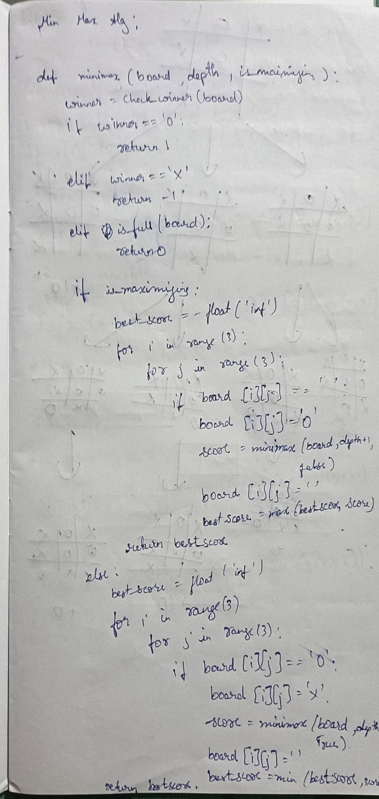 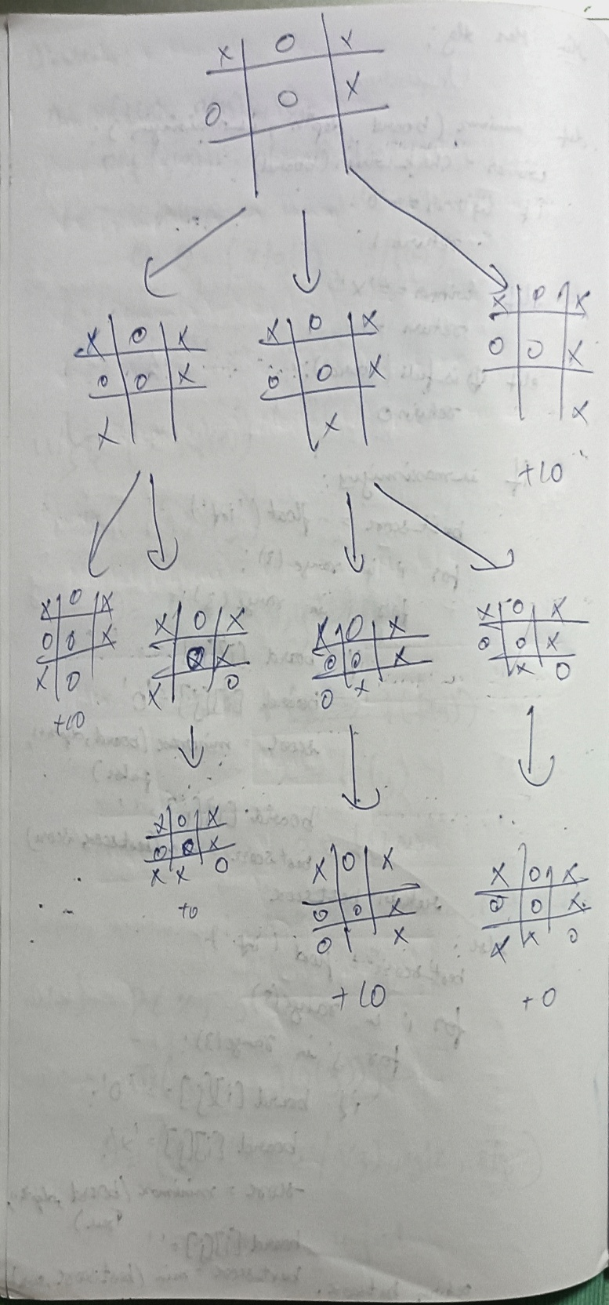

**Code:**

import math

# Alpha-Beta Pruning Algorithm

def alpha_beta(depth, node_index, maximizing_player, values, alpha, beta, max_depth, path, pruned): # Base case: leaf node

if depth == max_depth:

return values[node_index], [node_index]

if maximizing_player: best = -math.inf best_path = []

for i in range(2): # two children per node

val, child_path = alpha_beta(depth + 1, node_index * 2 + i, False, values, alpha, beta, max_depth, path, pruned) if val > best:

best = val

best_path = [node_index] + child_path alpha = max(alpha, best)

if beta <= alpha:

pruned.append((node_index, "Right" if i == 0 else "Left"))

break

return best, best_path else:

best = math.inf best_path = [] for i in range(2):

val, child_path = alpha_beta(depth + 1, node_index * 2 + i, True, values, alpha, beta, max_depth, path, pruned) if val < best:

best = val

best_path = [node_index] + child_path beta = min(beta, best)

if beta <= alpha:

pruned.append((node_index, "Right" if i == 0 else "Left")) break

return best, best_path

# Example usage

if name == " main ":

# Example game tree (leaf node values) values = [3, 5, 6, 9, 1, 2, 0, -1]

print("Leaf Node Values:", values) path = []

pruned = []

max_depth = 3

result, best_path = alpha_beta(0, 0, True, values, -math.inf, math.inf, max_depth, path, pruned)

print("\nOptimal Value at Root Node:", result) print("Best Path (Node Indices):", best_path) print("Pruned Nodes:", pruned)

**Output:**

